Justin Schneider

CSCE 520

HW1

Question 1: What are the ACID properties of transactions?

Atomicity: all-or-nothing of the transaction’s effect will take place

Consistency: each transaction leaves the system in a consistent state

Isolation: each transaction must appear to be executed as if no other transactions are executed

at the same time.

Durability: effect of a transaction must never be lost after the transaction is completed.

Question 2: Consider Figure 2.10 in the “A First Course in Database System” on page 35. Show a different way of representing the primary key. What is the difference between declaring a key using “Unique” or “Primary Key”?

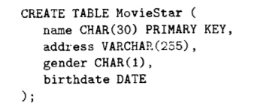

The primary key can be represented as shown in figure 2.9 since it is just one attribute.

Primary key:

* There can only be on primary key in a table
* It cannot be NULL
* Primary key is a unique identifier of the record

Unique Key:

* Can be more than one unique key in one table
* Unique key can have NULL values and may not be unique
* It can be a candidate key

Question 3: Exercise 2.2.3 on page 29.

a) 3! \* 3! = 36

b) 4! \* 5! = 2880

c) n! \* m!